**PROJECT PLANNING PHASE**

**Project Planning Template (Product Backlog, Sprint Planning, Stories, Story points)**

|  |  |
| --- | --- |
| Date | 18 NOV 2022 |
| Team ID | **PNT2022TMID39009** |
| Project Name | Emerging Methods for Early Detection of Forest Fires |
| Maximum Marks | 8 Marks |

## Product Backlog, Sprint Schedule, and Estimation (4 Marks)

|  |  |  |  |  |  |  |
| --- | --- | --- | --- | --- | --- | --- |
| **Sprint** | **Functional Requirement (Epic)** | **User Story Number** | **User Story / Task** | **Story Points** | **Priority** | **Team Members** |
| Sprint-1 | Import the Required, Collecting the Dataset | USN-1 | To analyze the fire prone areas and to set the surveillance camera to collect and observe the region continuously for early detection. | 1 | High | Chandru R  Manikandan V |
| Sprint-1 | Image processing | USN-2 | The collected data are categorized on the basis of parameters set to identify. To train the  model, CNN is used to test repeatedly by storing the datasets in server. | 1 | High | Chandru R  Manikandan V |
| Sprint-2 | Model Building, Reviewing the model | USN-3 | The main task is to check that the model is efficient to work in real time. Therefore, smallest of error detected need to be corrected to avoid future  lags, after testing all functionalities, it is been implemented. | 2 | High | Chandru R  Manikandan V |
| Sprint-3 | Video analysis, Sending alert message | USN-4 | The video Analysis of the model must be recorded. The model should connect with API  named Twilio, which receives & sends the management with messages. | 2 | High | Chandru R  Manikandan V |
| Sprint-4 | IBM cloud deployment | USN-5 | The model should connect with API named Twilio, which receives & sends the management with messages. | 2 | High | Chandru R  Manikandan  V |

**Project Tracker, Velocity & Burndown Chart: (4 Marks)**

|  |  |  |  |  |  |  |
| --- | --- | --- | --- | --- | --- | --- |
| **Sprint** | **Total Story Points** | **Duration** | **Sprint Start Date** | **Sprint End Date (Planned)** | **Story Points**  **Completed (as on Planned End Date)** | **Sprint Release Date (Actual)** |
| Sprint-1 | 20 | 6 Days | 24 Oct 2022 | 29 Oct 2022 | 20 | 29 Oct 2022 |
| Sprint-2 | 20 | 6 Days | 31 Oct 2022 | 05 Nov 2022 | 15 | 06 Nov 2022 |
| Sprint-3 | 20 | 6 Days | 07 Nov 2022 | 12 Nov 2022 | 10 | 14 Nov 2022 |
| Sprint-4 | 20 | 6 Days | 14 Nov 2022 | 19 Nov 2022 | 5 | 20 Nov 2022 |

## Velocity:

Imagine we have a 10-day sprint duration, and the velocity of the team is 20 (points per sprint). Let’s calculate the team’s average velocity (AV) per iteration unit (story points per day)

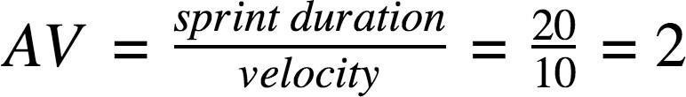

## Burndown Chart:

A burn down chart is a graphical representation of work left to do versus time. It is often used in agile [software development](https://www.visual-paradigm.com/scrum/what-is-agile-software-development/) methodologies such as [Scrum](https://www.visual-paradigm.com/scrum/scrum-in-3-minutes/). However, burn down charts can be applied to any project containing measurable progress over time.

**STORY POINTS**

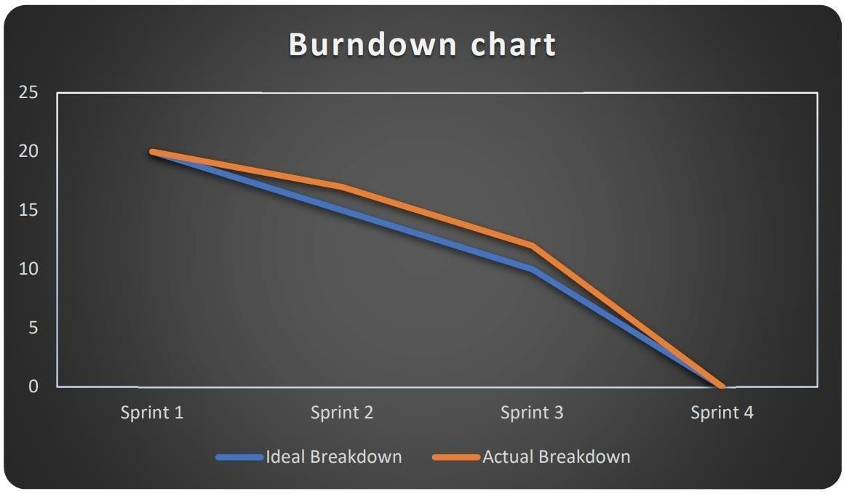

# SPRINT STAGES